**Matthew Halliday 19/09/17**

## Introduction

The following code and screenshots give examples of producing shapes and making art using code. This is done using a program called ‘Processing’, which is Java based.

The exercises demonstrate the use of procedural programming, using variables, functions, loops and conditional statements (e.g IF statements).

The comments in the code descript what it’s doing.

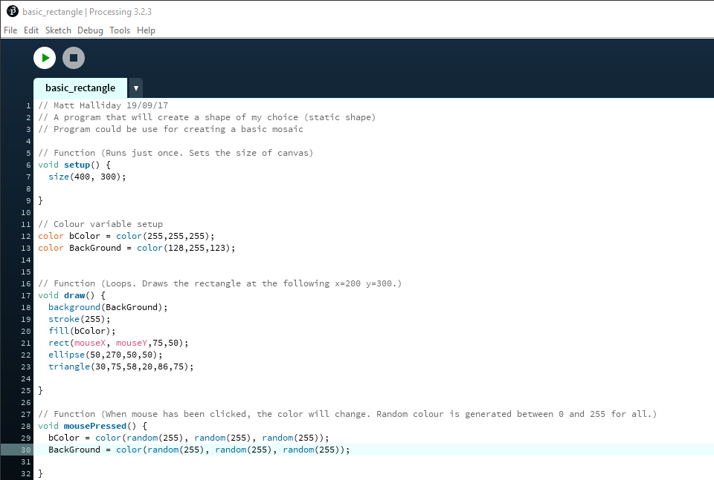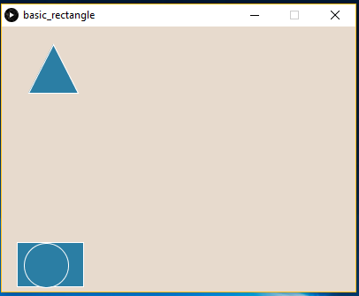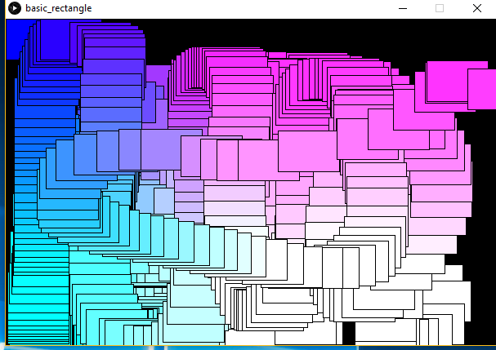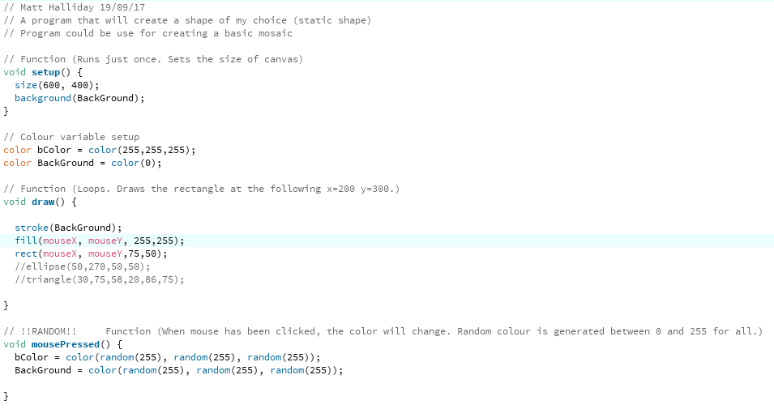

Set canvas smaller when circle is moved will create rainbow affect. (made code smaller)

